**S1 Figure**

Training and testing results for 10-fold validation.

Here we present the accuracy and loss for each fold during the training process.

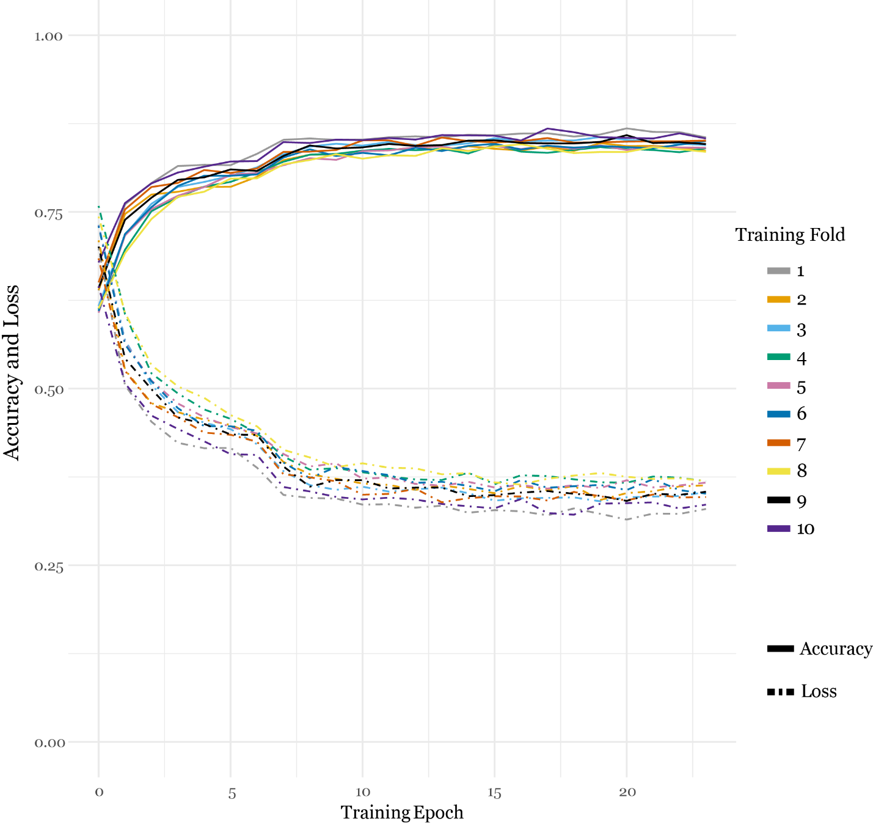

The testing results for each fold.

XXXX